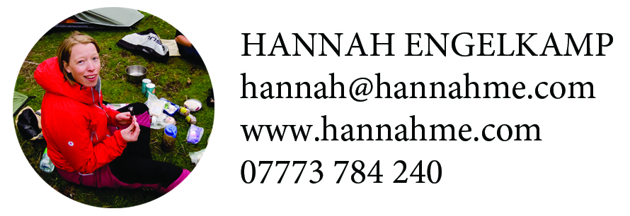

How to write for the web

Who are you writing for?
When writing for the web, you are really writing for scanners with short attention spans and little patience. You’ll know from the way that you use the web yourself that if you don’t get the answer you want within seconds, you click away.

Most of the specific things to bear in mind when writing for the web are simple, common-sense ways of making the text easy to scan, and the meaning easy to grasp.

Content: what your text says

What is your point?
Most web pages will only show a title and a paragraph or two before you have to scroll down. Scanners will only scroll down if they see something encouraging right away, so load your title, standfirst and first paragraph with all of the juiciest stuff. Get right to the point – don’t be tempted to save the best till last or no-one will get there.

Think of a good title
The title should be informative and/or intriguing. It should not be more than two lines long, and if you can keep it to one line, even better.

Make subheadings informative
Subheadings must explain the following text, and must not repeat the heading.

Get rid of unnecessary words
Put your point across in as few words as you can. Several mathematical methods exist to calculate the readability of text, and all take into account the number of words per sentence and the number of three-or-more syllable words in the text. None of them would like ‘unnecessary’, ‘mathematical’ or ‘readability’. Find a shorter word if you can. If you want to check your text’s readability you can paste it into this calculator: https://readable.io/text/ (Take it with a pinch of salt!)

Write simple and friendly text
- Use ‘you’ and ‘we’ in the text – it’s very engaging
- You don’t need to think of complicated ways to avoid using the same words several times. If they are the most important words, just use them again

Forget about order
The user will not be looking through your pages with the logic of a book – they will be flitting about. Each page, and even paragraphs within a page, should stand alone.

Form: how the text looks

Short, simple paragraphs of short words
A big block of text looks like an effort to read, and is easy to click away from. Instead your text should be cut into bite-sized paragraphs with short sentences and short words. As a rule of thumb:

- Headings: fewer than eight words
- Sentences: fewer than 20 words
- Paragraphs: fewer than 10 sentences (the BBC likes just one sentence per paragraph!)
- Pages: fewer than 500 words, and 250 is much better
- Headings and paragraphs should contain no widows (A widow is when the last word in a paragraph sits alone on a line, as is happening below. When you get a widow make sure you add or take away a few words to neaten the text)

Make the important bits stick out
- Use subheadings wherever you can – this will also make you evaluate the point of the paragraph. Make the subheads informative – scanners will look through these entry points to see if there is anything they want to read
- Feel free to bold up the most important words in the text; this will draw the scanners’ attention. But the scanning eye can only pick up three words at once, so don’t bold up whole sentences. Also, look at your bolded words alongside your underlined links to check that they look sufficiently different. If the bold words look like links but aren’t then it will annoy people. In this case, do without bolded words.
- Use bullet points like these if it makes the text easier to read

What do search engines want?

Search engine optimisation (SEO) is the practice of making your site or page easy for search engines (like Google) to find. There is an ever-changing art and science to this, as search engines tweak their algorithms.

Google takes some time to get around to analysing new pages, and a crowdfunding campaign doesn’t usually have enough lead-in time to make a search engine optimisation focus worthwhile in advance of your campaign.

Most people will get to your page by following a direct link from one of the many dozen places you will be leaving it – newsletters, social media, guest blogs, lamp posts etc, rather than asking Google with search terms.

However, it is still worth considering the words you use. It will make it a friendly page for the reader, and may have a positive knock-on effect for SEO too. People who are interested in your subject are more likely to find your campaign by mistake. Also, even when your campaign is over, it will still be on the crowdfunding site’s archives, so people may still find you that way.

If you’ve followed all of the rules so far you’re well on the way to making your text Google-friendly. What Google rates most of all is genuine, helpful text that is well laid out and has links to other relevant pages.

Test yourself. What don’t you like?
Stop yourself and look at a webpage that you were about to click away from and ask yourself, “What did I not like about that page?” The answer will probably be that there was an absence of the thing you were looking for, not the presence of something you didn’t like.

So, what is the question your reader will be asking?
Your reader is coming to your text to accomplish a task. They want to find something, and you need to make it easy to find. (In the case of blogs or bits of news they might be looking for entertainment or further understanding. On other pages they are probably looking for specific information. On a crowdfunding campaign page they are looking to be generally reassured of your credentials, authenticity and trustworthiness, and to have their questions – the who, what, where, when, how and why of your proposal – answered as swiftly and simply as possible.)

Before you start writing or editing the piece of text make a quick list of the words and phrases people might have used to look for this page.

Good linking

Make sure your links are useful
A good link is one to a page with similar words on it – this is how Google determines the relevance of links

Don’t ‘click here’!
Writing ‘click here’ is old fashioned!

Make your links friendly
The text should make it clear what you are linking to. If it is a download make sure you say so: “Download a fact sheet here”, for example.

Click for more?
If your page is getting too long and you want to add a ‘More’ link at the bottom, make sure that the text before the end is juicy, so that people want to click and read more!

Checklist

Before you start writing
What is the point of the page?
What is the point of each paragraph?
Where will people have come to your page from?
Where would you like them to go next?
What words will they be looking for? Make a mental list of keywords

As you write
Is that the simplest way of writing that sentence?
Are the words that people will be looking for in there?
Are you using short words?

Spit and polish
Are you adding links throughout the text?
Have you bolded up some important words?
Have you added informative subheadings?

